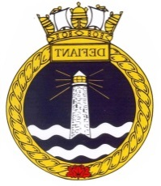
338 RCSCC DEFIANT
TRICORPS WEEKEND
Saturday 17 November 2018 & Sunday 18 November 2018

EVENT: Tricorps Weekend
LOCATION: Connaught Ranges, 5 Brouilette
TIMINGS: To be confirmed
TRANSPORTATION: To dropped off and picked up by parents
ALL CADETS MUST ENSURE THAT THEY HAVE THEIR HEALTH CARDS WITH THEM
This weekend event will be taking place with two other corps, 319 Centurion and 211 Lanark with a focus on small party tasking, sports and team building. More information will be provided as soon as it is available. Electronic devices that are brought are YOUR responsibility.
In case of emergency contact Lt(N) Tousaw 613-858-2675 or A/Slt Churchill 613-325-8055
Permission Forms are due back no later than Monday October 29, 2018.
KIT LIST
Health Card Sleeping Bag/blanket
Pillow Sleeping Cot or Mat
Pajamas Appropriate Civilian Clothes
PT Gear, running shoes Warm Hat
Gloves/Mitts Warm Coat
Toiletries Flashlight
Refillable, labelled Water bottle

----------------------------------------------------RETURN TO CORPS BY MONDAY OCTOBER 29, 2018--------------------------------------------------------
TRICORPS WEEKEND
Saturday 17 November 2018 & Sunday 18 November 2018

I, the undersigned, grant permission for my son/daughter ______________________________________
to participate in the the Tricorp weekend at Connaught 17-18 November 2018.
_____________________________ ____________________________________
Parent name Signature
_____________________________ ____________________________________
Date Contact Number

